Shubham Sarda (2018TT10958) Ankit Kumar (2020CS10323)

**COP 290 Assignment 2: *MAZE MANIA***

This is a 2-player adventure game set up in the IIT Delhi campus. Your game avatar has to navigate through the maze/campus and complete several tasks to score points. Finally, the player with higher number of points wins the game. Now, we’ll briefly go through the different aspects of the game.

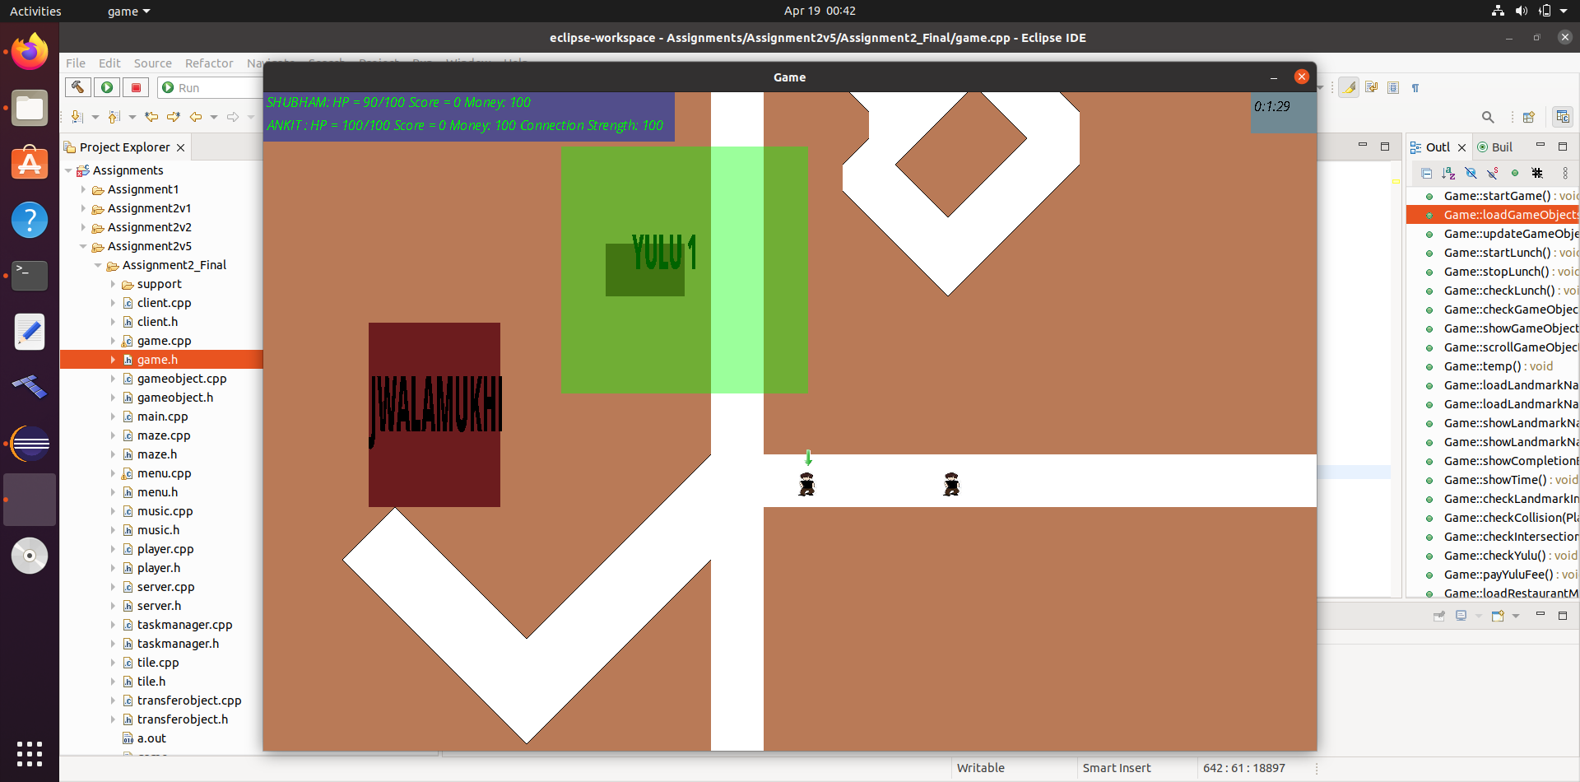

**Menu Screen:**

Note: You can toggle game music on/off by pressing M. Similarly, press ‘F’ to toggle full screen and ‘Esc’ to exit the game.

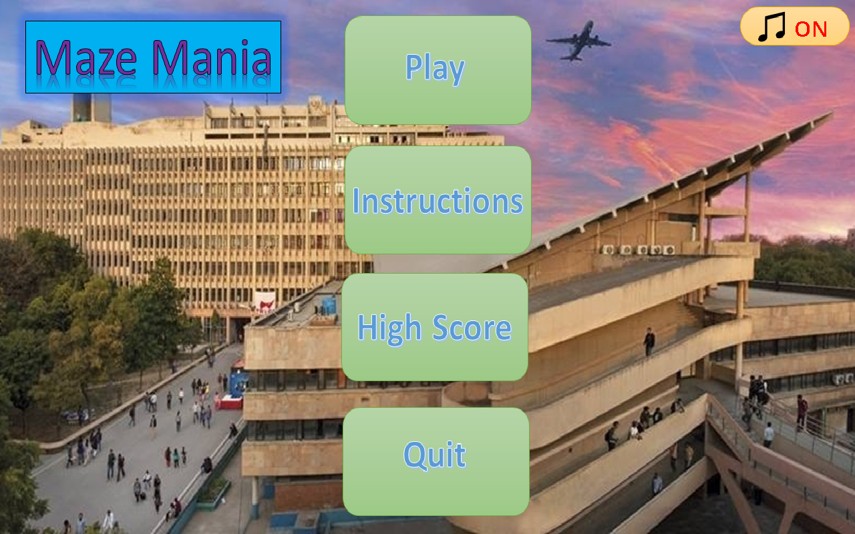

You can click on “Instructions” to learn more about the game objectives. In order to view the current high score, click on “High Score”. Finally, click on “Play” to begin the game.

After clicking on “Play”, you’ll view an input screen where you’re required to type your name, hostel and game time. You’re also required to input give client/server identification. In case you’re the server, also provide correct IP Address of the server you want to join.

Note: 1. Out of the 2 players, one must be server and other client. 2. Hostel name must be correctly spelled. Now, once you click “Enter”, you’ll be directed towards the game.

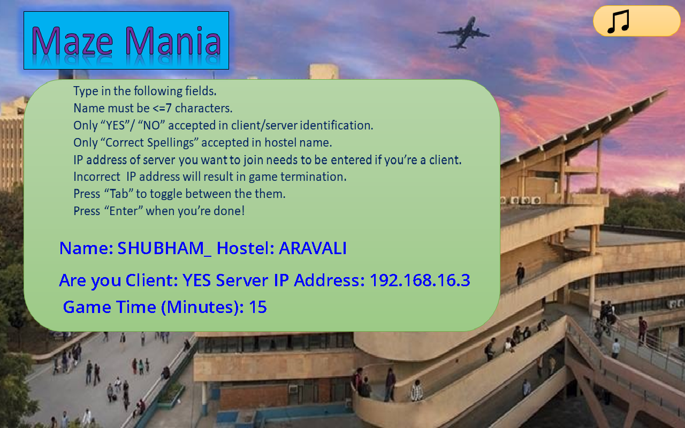

**MAP:**

We’ve used Tiled application (<https://www.mapeditor.org/>) to create the map/maze. IITD map from <http://smp.iitd.ac.in/freshers.html> has been used to create the game map.

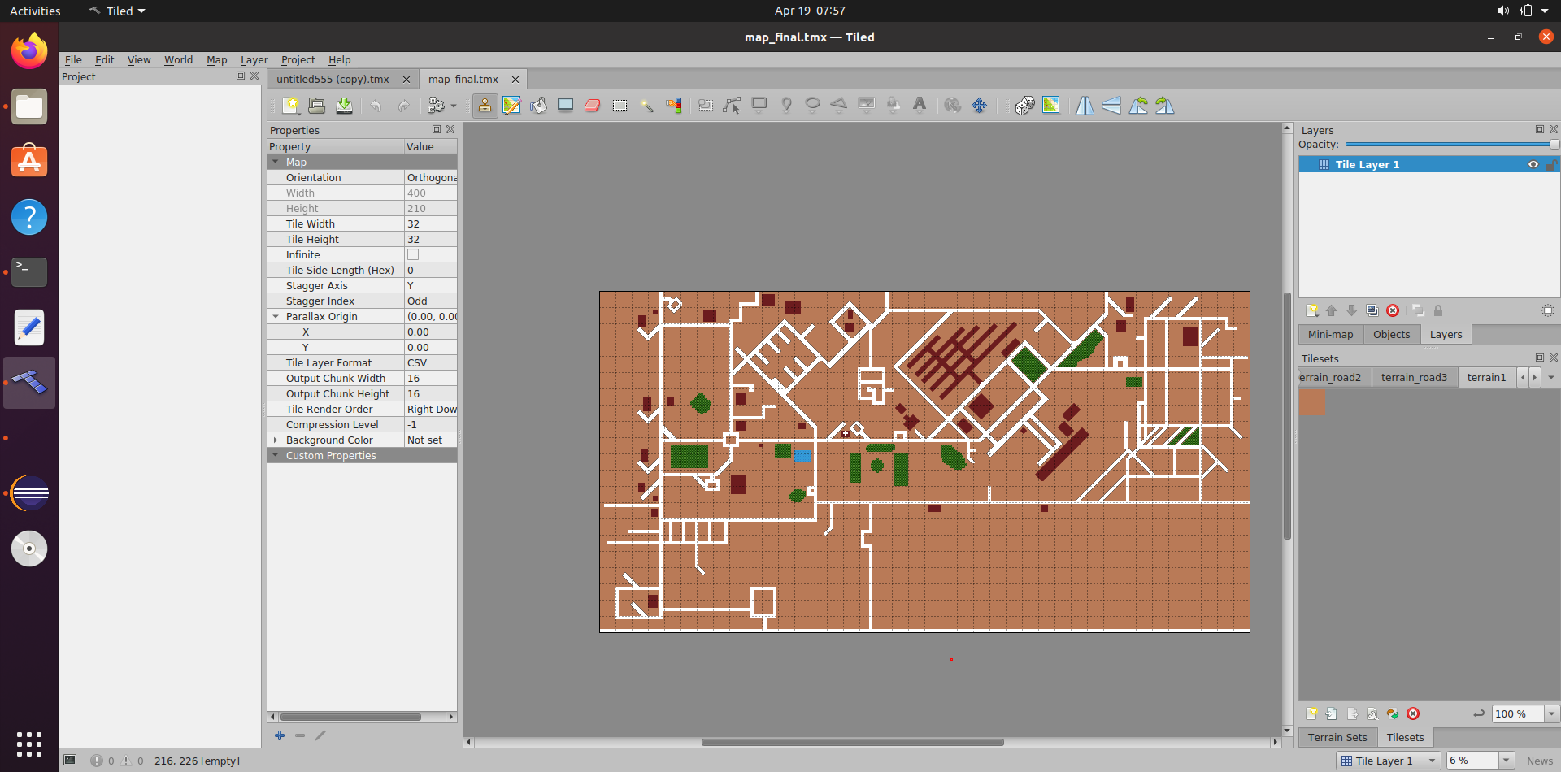

Note: Appropriate Landmark names have been rendered in the game using SDL-TTF library.

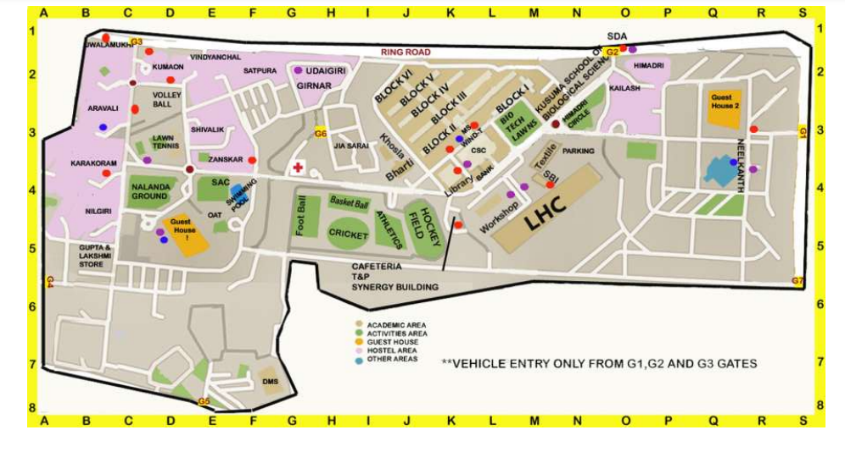

Reference Image

**YULU:**

There are four YULU stations across the campus (NILGIRI, SAC, JWALAMUKHI and LHC), from where you can rent a YULU @ 0.5$/second. Once you reach a YULU stand, press “k” to start renting. On renting a YULU, your speed doubles. You can only drop YULU at a YULU station. Time between renting and dropping will be used to calculate the total rent. In case, you’re out of money, YULU automatically disappears.

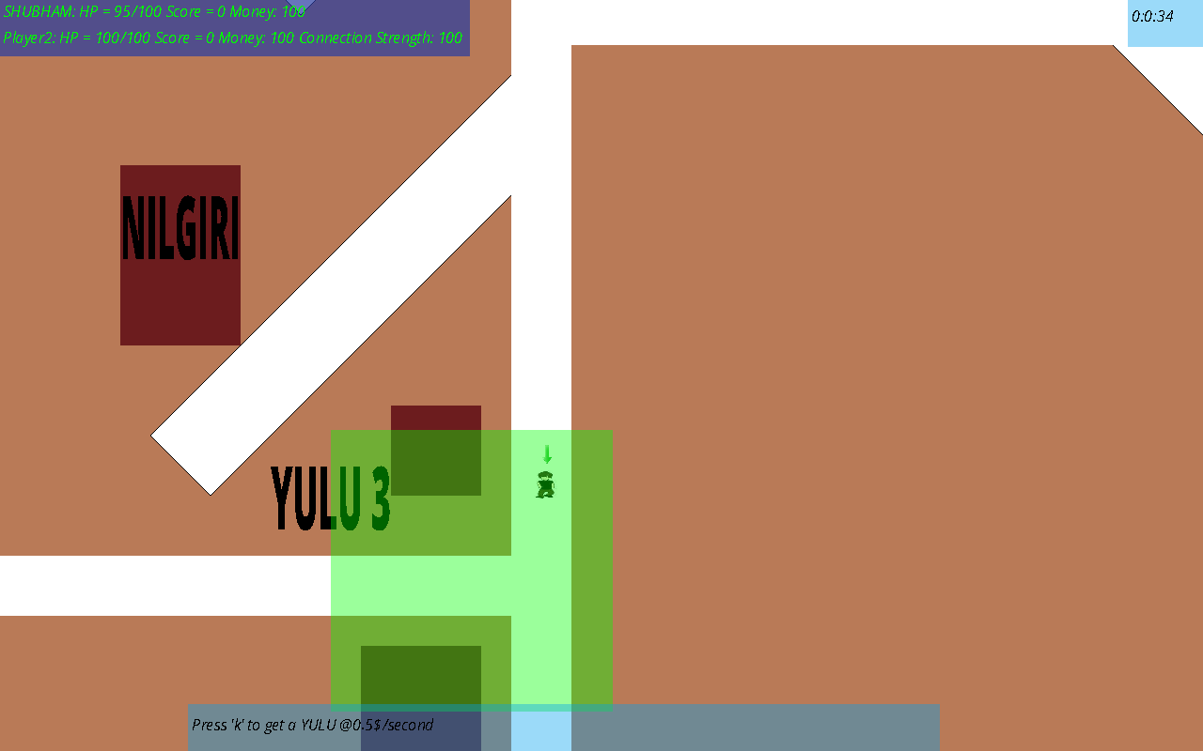

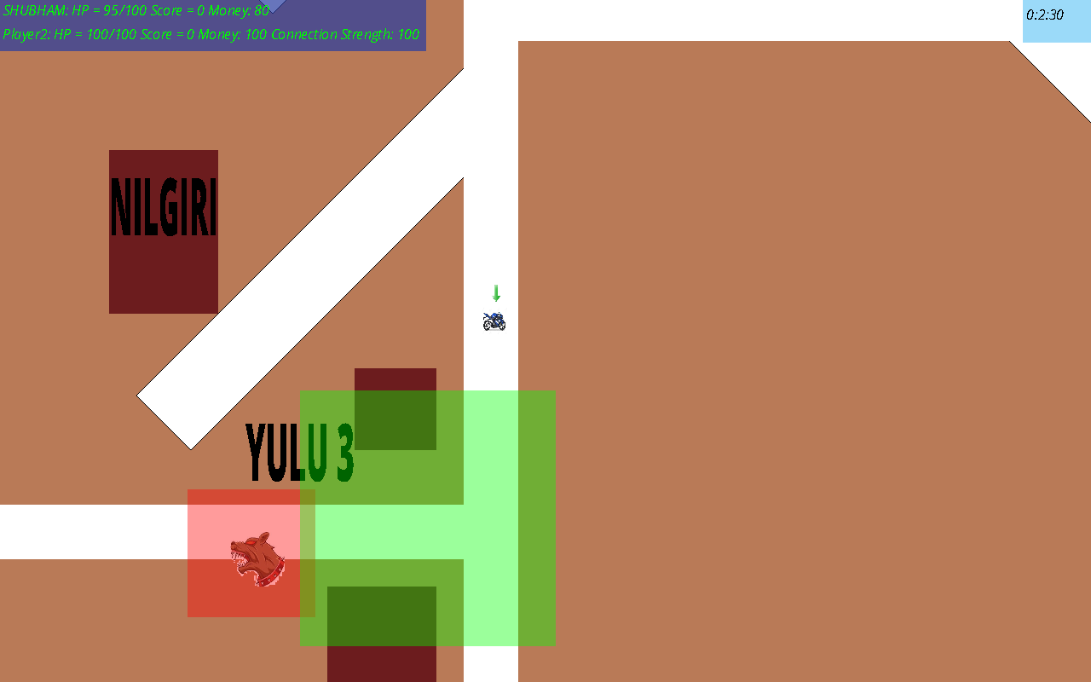

**Lunch:**

After every 5 minutes, you’re required to have lunch/dinner, or you lose 20 hp. To have lunch/dinner, go to your hostel. After the start of lunch time, you have a 1-minute window to reach your hostel.

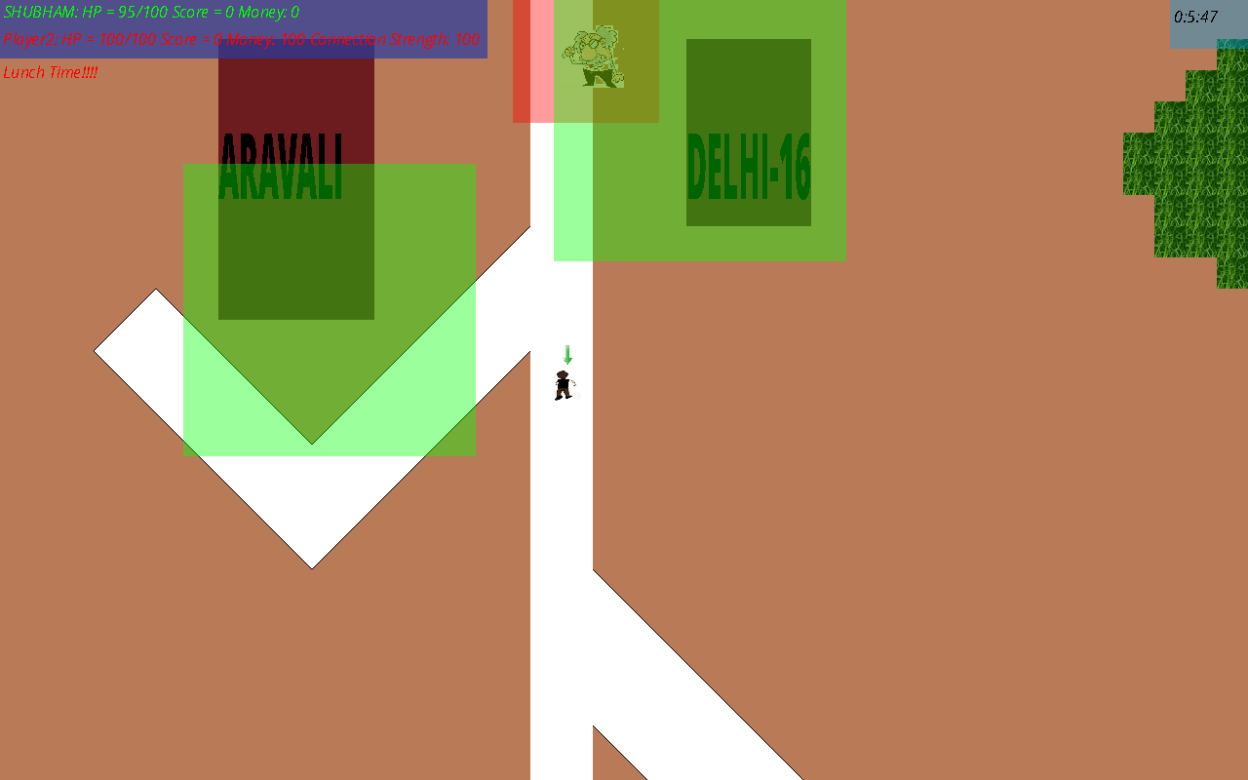

**Game Objects:**

There are several game objects randomly appearing in the game.

1. Money: If you collect this, your total money increases by 30.
2. Angry Professors: On meeting angry Professor, your hp reduces by 5.
3. Angry Dogs: On coming in contact with these, your hp reduces by 10.



**Eateries:**

If your low on hp, you can visit any of the three restaurants present across the campus: Delhi-16, Masala Mix, Staff Cafeteria. Buy the item you want to eat once you enter the restaurant.

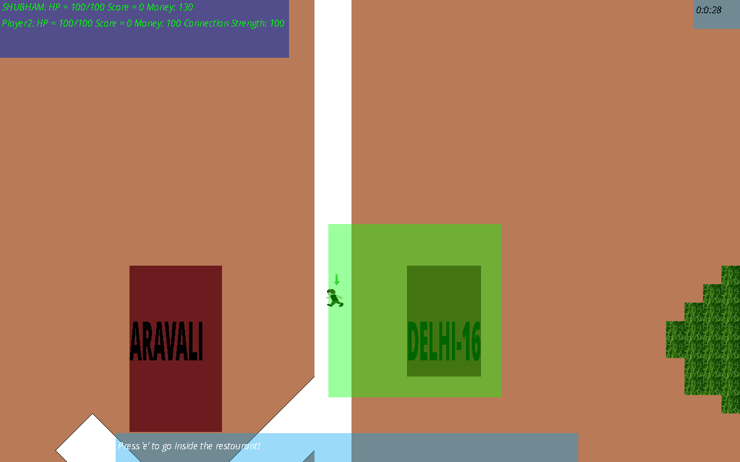

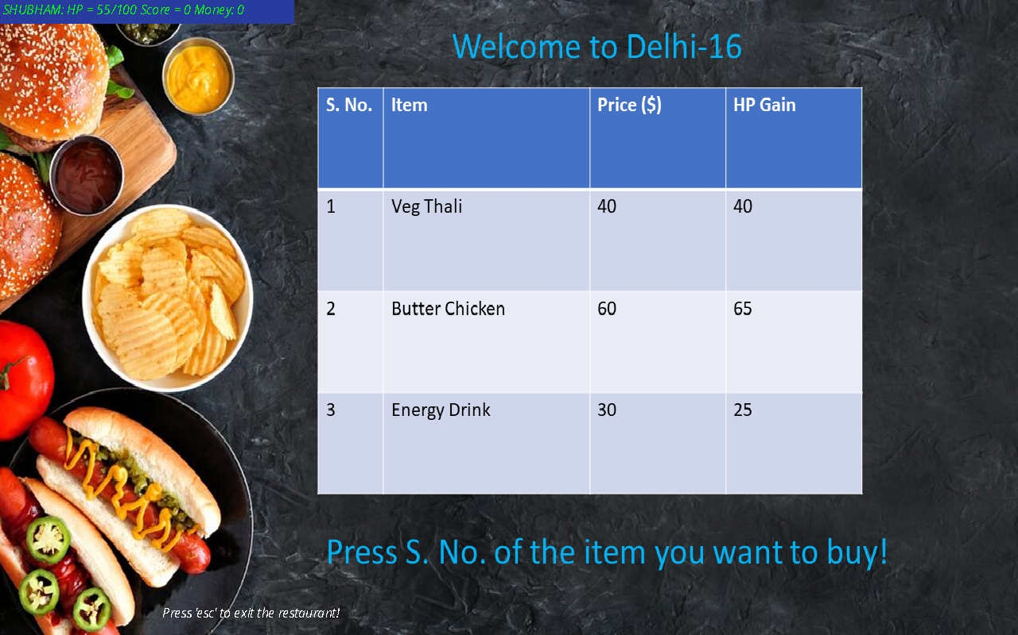

**Inspector Gadget:**

There is a special inspector gadget store towards the south of NILGIRI Hostel. Visit the store to buy cool gadgets/game boosts!

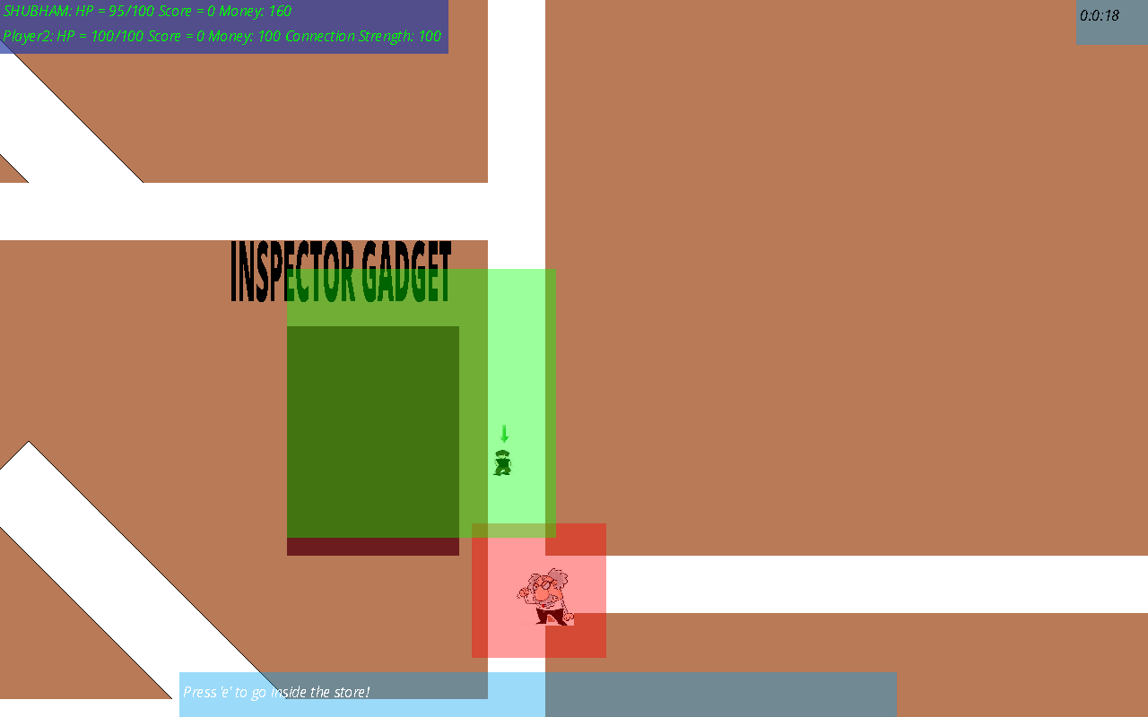

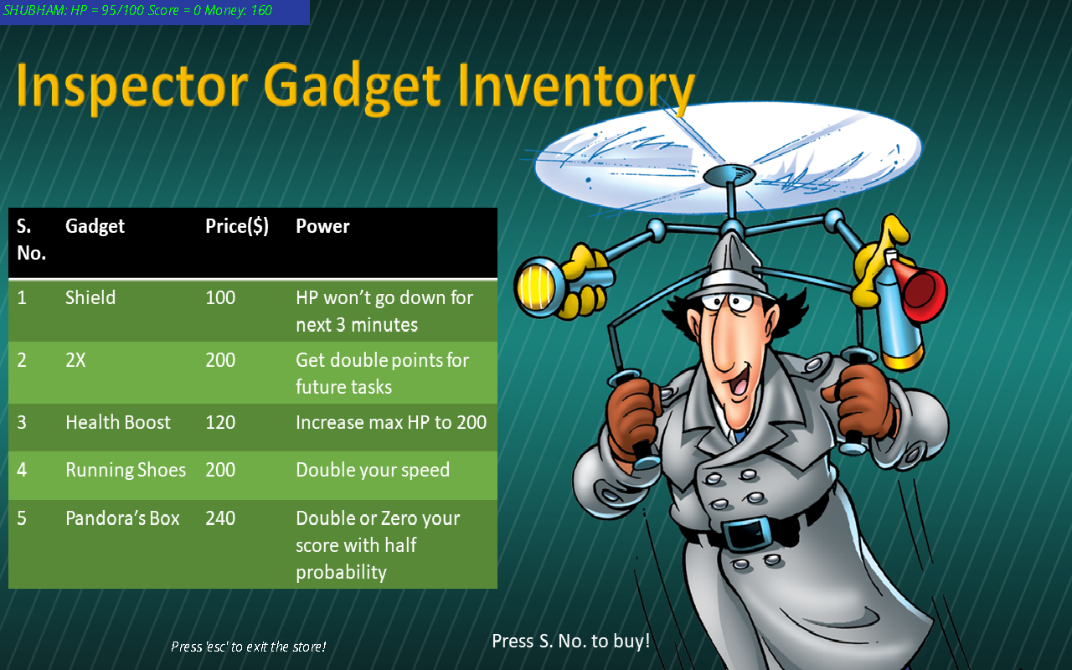

**Bank:**

You can visit SBI Bank (near LHC) to deposit/withdraw money as and when you need. You receive simple interest on the amount deposited @10% every minute.

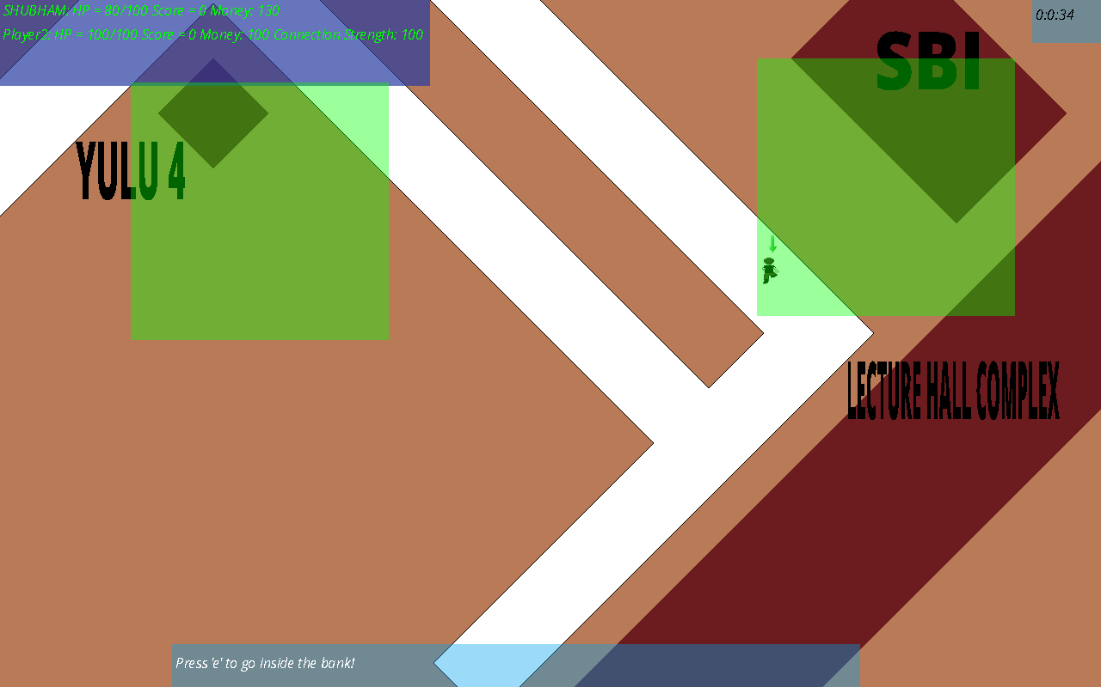

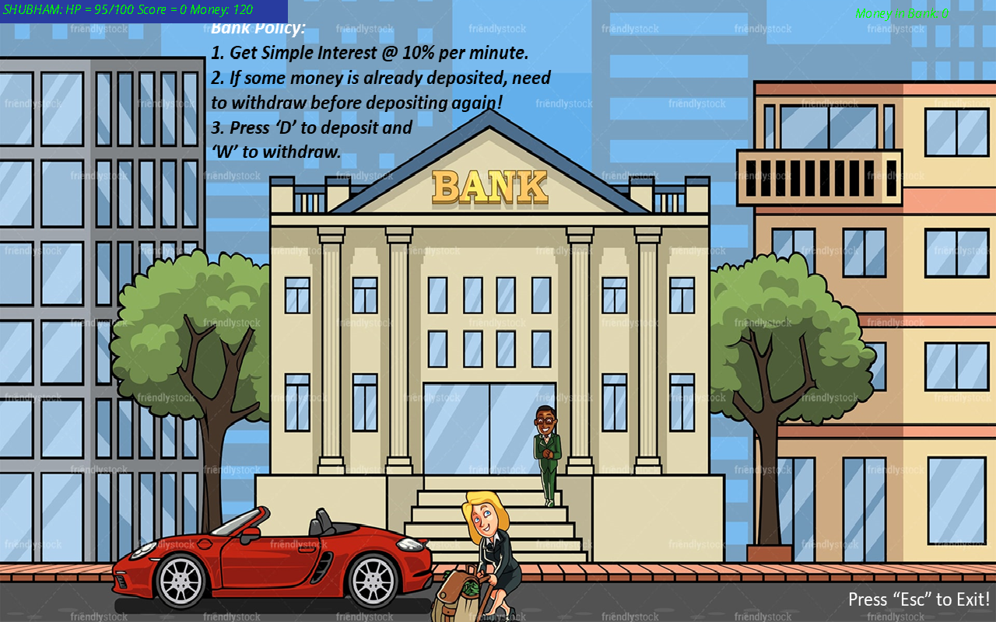

**Task Manager:**

This is the most important aspect of the game. You have to complete tasks to increase your game score, which wins you the game. The less time you take to complete the task, higher the number of points you score. There are a total of 10 tasks which are assigned you to you in a random order every time you play the game. Press “T” during the game to open up the task manager UI.

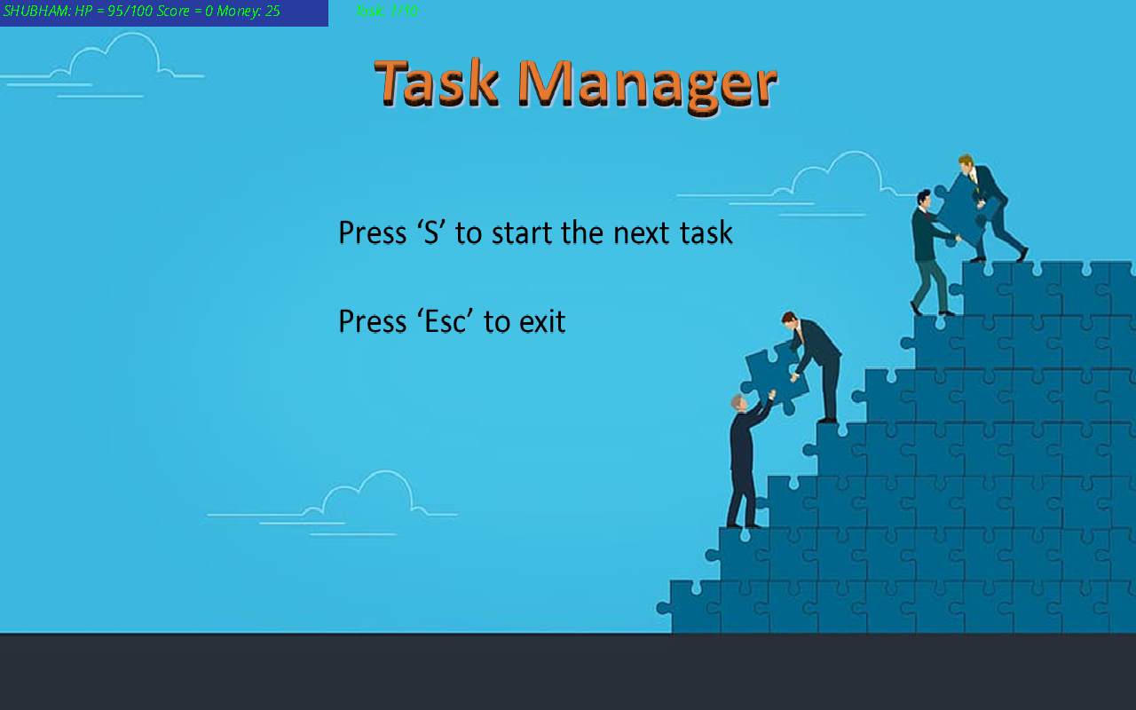

**Completing The Tasks:**

In order to complete the task, follow the instructions mentioned in the task manager window.

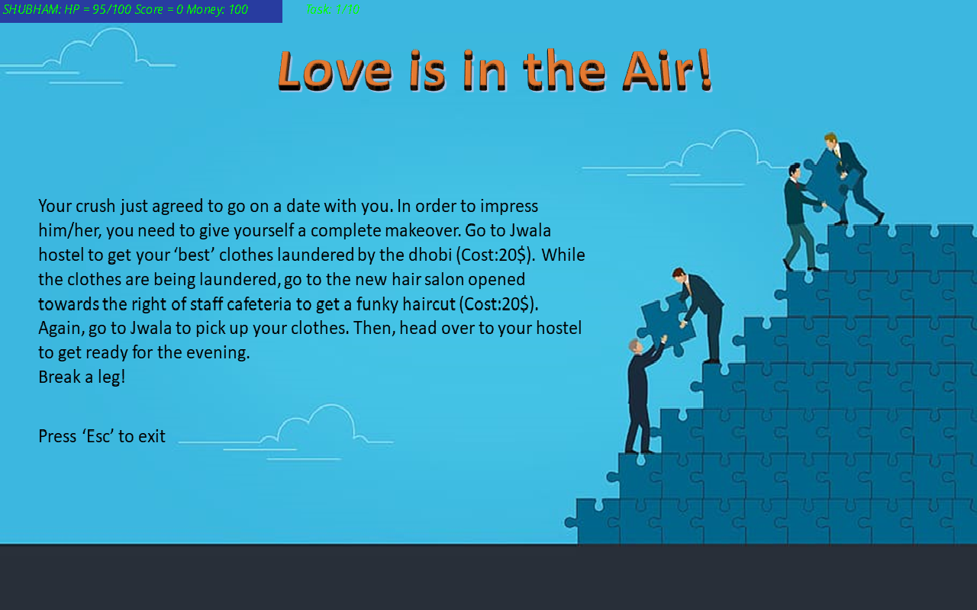

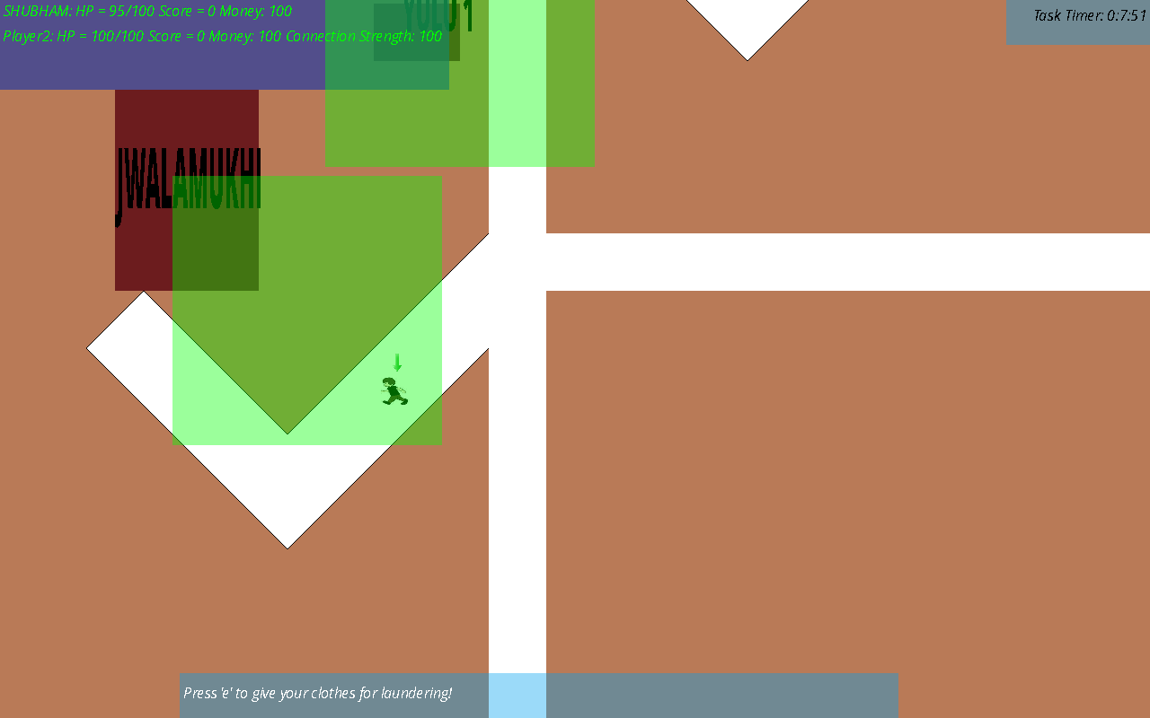

To complete this you have to first Jwalamukhi hostel for laundering the clothes. Similarly go to next landmarks mentioned in the task manager window and complete the task.

Note: Some tasks can also require you to have a certain amount of money. For instance, here you need a total of 40$ to complete the task!

**Another Task:**

The game is full of exciting tasks. One of which is the **“FOOTBALL FANATICS”** task. Here you have to score goals using a mix of mouse/touchpad and keyboard inputs.

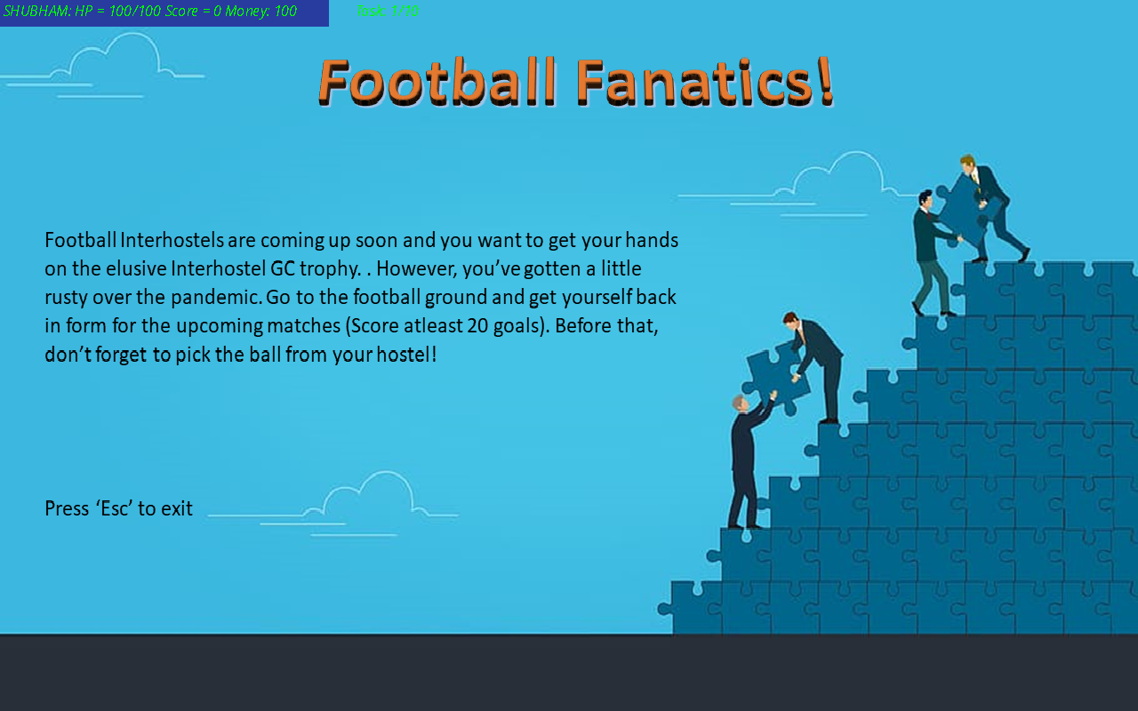

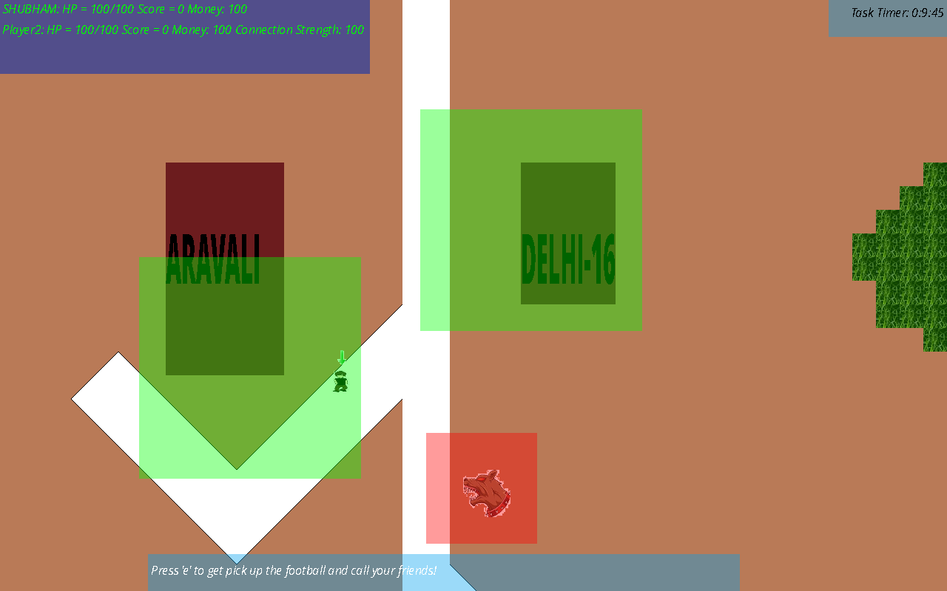

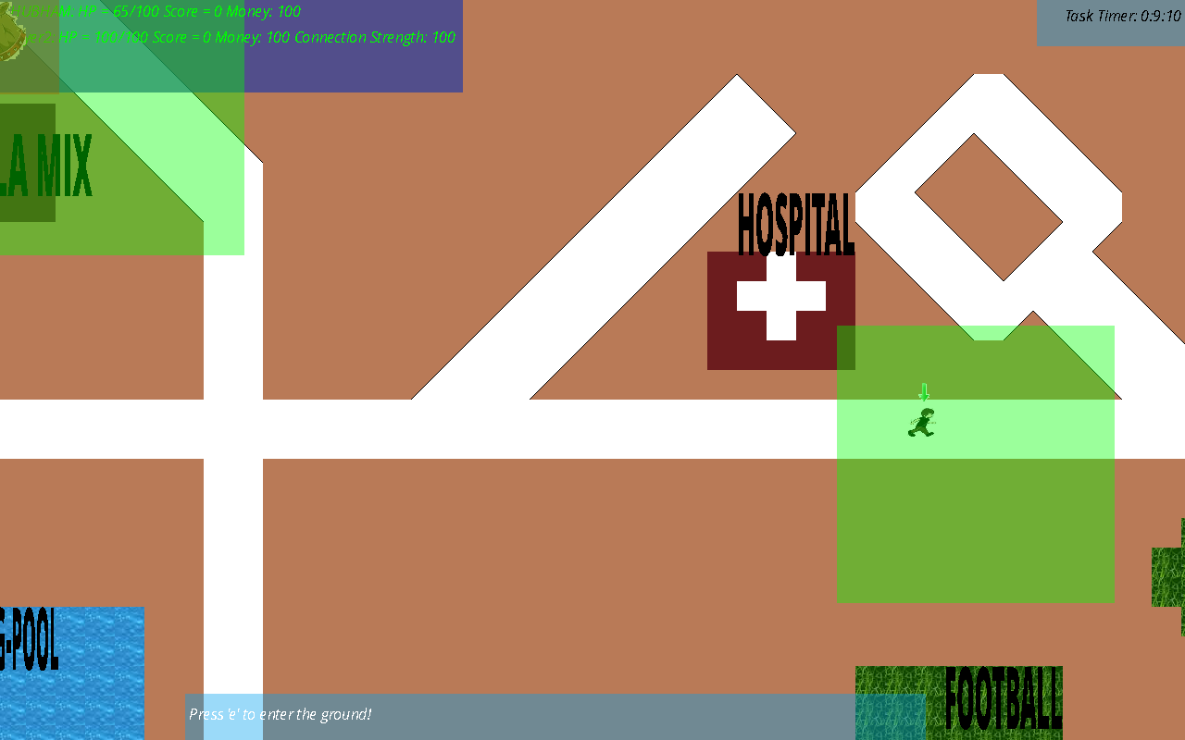

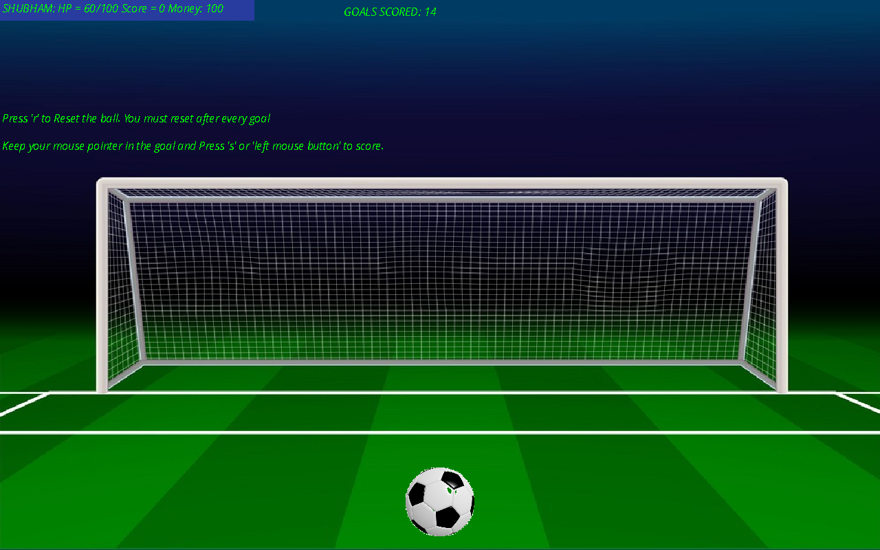

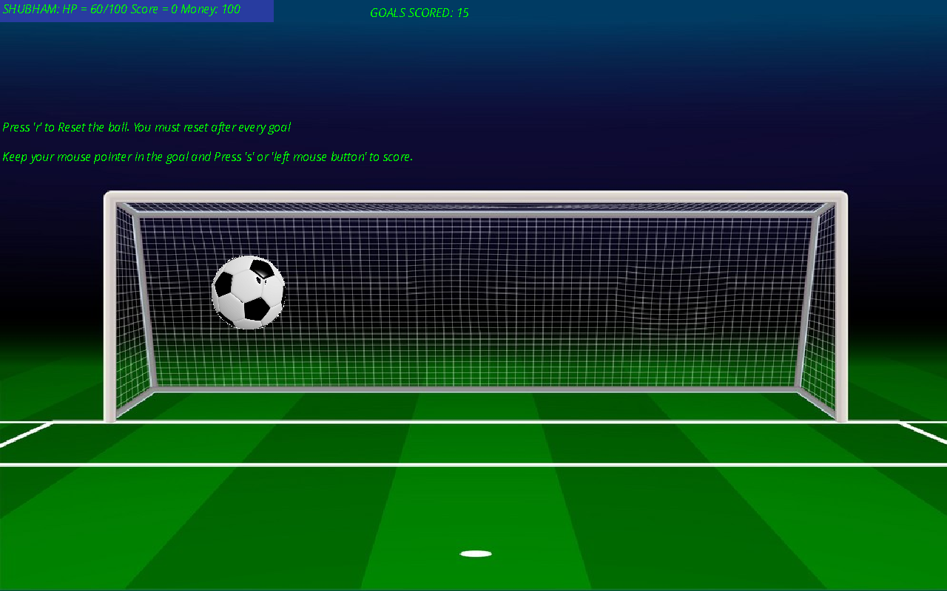

**Winning the Game:**

If a players hp reduces to 0, then the opponent automatically wins the game. In case the game proceeds till the end (game time taken as input during start of the game), the one with higher score wins the game. If scores are tied, preference is given to one with higher hp (or money if hp also equal).